Supplementary Information for :

**Predicting predator search rates from metabolic rates: a bottom-up modelling approach.**

Flavio Affinito1, Miguel Matias2, Samraat Pawar1 and Rebecca L. Kordas1

*1. Department of Life Sciences, Imperial College London, Silwood Park Buckhurst Road, SL5 7PY, Ascot UK*

*2. Museo Nacional de Ciencias Naturales (CSIC), Madrid, 28006, Spain*

**Corresponding author.** *E-mail: flavio.affinito@gmail.com*

Table of Contents

MODELLING 1

Search rate model derivation 1

Dimensionality effect 1

Biological rates and temperature-dependence 2

Velocity estimation 3

Respiration model choice 3

EXPERIMENTS 4

Species selection 4

Length-weight regression 4

Respirometry protocol 5

# MODELLING

## Search rate model derivation

We are interested in expressing search rates relative to predator-prey trait temperature dependence and accounting for environmental space. Search rates are given as a function of relative body velocities and environmental space (Dell, Pawar and Savage, 2011, 2014, Pawar, Dell and Savage, 2012, 2015; Gilbert *et al.*, 2014):

$$a= v_{r}D$$

### Dimensionality effect

The dimensionality component *D* for equation S1 expands into (Pawar, Dell and Savage, 2012):

$$D=d^{\left(D_{m}-1\right)}s_{D}$$

Species interactions in nature can be defined as either 2D (*Dm*=2 ;*sD*=2) or 3D (*Dm*=3 ;*sD*=π) dependent on the environment they interact in. In this component, *d* is the detection distance of a predator and is dependent upon the respective body masses of the predator-prey pair :

$$d= d_{0}{\left(m_{r}m_{c}\right)}^{p_{d}}$$

Where *d0*  is the minimum detection distance, *mr* and *mc* are prey and predator mass respectively and *pd* is the empirical scaling exponent of dimensionality(Pawar, Dell and Savage, 2012). Thus when considering the effect of dimensionality on search rates, we obtain two scenarios :

$$2D:D=2d_{0}{\left(m_{r}m_{c}\right)}^{p_{d}}$$

$$3D:D= π{\left(d_{0}{\left(m_{r}m_{c}\right)}^{p_{d}}\right)}^{2}$$

### Biological rates and temperature-dependence

Relative body velocity is expressed as (Dell, Pawar and Savage, 2011, 2014):

$$v_{r}=\sqrt{{v_{r}}^{2}+{v_{c}}^{2}}$$

Where *vr* and *vc* are prey and predator body velocities respectively. Here, we consider two interaction cases, one where prey species are relatively sessile compared to the predator ($v_{r}≈v_{c}$) and one where both predator and prey are in active movement and equation S5 holds true. Predator and prey velocities as a biological rates scale with temperature and mass:

$$v_{c,r}=b_{0_{c,r}}{m_{c,r}}^{β_{c,r}}e^{\frac{{-E}_{c,r}}{k}\left(\frac{1}{T}-\frac{1}{T_{ref}}\right)}$$

Where c and *r* subscripts apply to predator and prey respectively, *bO* is the baseline trait performance at a reference temperature (*Tref*), *m* is mass, *β* is the mass scaling exponent, *E* is activation energy and *T* is temperature. Hence when the prey is considered sessile we get:

$$2D:a=b_{0_{c}}{m_{c}}^{β_{c}}e^{\frac{{-E}_{c}}{k}\left(\frac{1}{T}-\frac{1}{T_{ref}}\right)}2d_{0}{\left(m_{r}m_{c}\right)}^{p_{d}}$$

$$3D:a=b_{0_{c}}{m_{c}}^{β_{c}}e^{\frac{{-E}_{c}}{k}\left(\frac{1}{T}-\frac{1}{T_{ref}}\right)}π{\left(d_{0}{\left(m_{r}m_{c}\right)}^{p_{d}}\right)}^{2}$$

When both predator and prey species are active we have :

$$v_{r}=\sqrt{{b_{0_{r}}}^{2}{m_{r}}^{{2β}_{r}}e^{\frac{{-2E}_{r}}{k}\left(\frac{1}{T}-\frac{1}{T_{ref}}\right)}+{{{b_{0_{c}}}^{2}m}_{c}}^{{2β}_{c}}e^{\frac{{-2E}_{c}}{k}\left(\frac{1}{T}-\frac{1}{T_{ref}}\right)}}$$

Hence:

$$v_{r}= b_{0_{c}}{m_{c}}^{β_{c}}e^{\frac{{-E}_{c}}{k}\left(\frac{1}{T}-\frac{1}{T_{ref}}\right)}+\sqrt{1+{\left(\frac{b_{0_{r}}}{b_{0_{c}}}\right)}^{2}{\left(\frac{{m_{r}}^{β_{r}}}{{m_{c}}^{β_{c}}}\right)}^{2}e^{\frac{2}{k}\left(\frac{1}{T}-\frac{1}{T_{ref}}\right)\left(E_{c}-E_{r}\right)}}$$

Thus for active predator-prey search rate models we have:

$$2D: a=\left[b_{0_{c}}{m_{c}}^{β_{c}}e^{\frac{{-E}_{c}}{k}\left(\frac{1}{T}-\frac{1}{T_{ref}}\right)}+\sqrt{1+{\left(\frac{b_{0_{r}}}{b_{0_{c}}}\right)}^{2}{\left(\frac{{m_{r}}^{β_{r}}}{{m_{c}}^{β_{c}}}\right)}^{2}e^{\frac{2}{k}\left(\frac{1}{T}-\frac{1}{T_{ref}}\right)\left(E_{c}-E_{r}\right)}}\right]2d_{0}{\left(m_{r}m_{c}\right)}^{p_{d}}$$

$$3D:a=\left[b_{0_{c}}{m_{c}}^{β_{c}}e^{\frac{{-E}_{c}}{k}\left(\frac{1}{T}-\frac{1}{T_{ref}}\right)}+\sqrt{1+{\left(\frac{b_{0_{r}}}{b_{0_{c}}}\right)}^{2}{\left(\frac{{m_{r}}^{β_{r}}}{{m_{c}}^{β_{c}}}\right)}^{2}e^{\frac{2}{k}\left(\frac{1}{T}-\frac{1}{T_{ref}}\right)\left(E_{c}-E_{r}\right)}}\right]π{\left(d_{0}{\left(m_{r}m_{c}\right)}^{p_{d}}\right)}^{2}$$

## Velocity estimation

The taxa used in this study are swimmers. The energetics of  swimming have been studied for various species (Videler and Nolet, 1990; Videler, 1993; Alexander, 2003). Assuming velocity scales linearly with metabolic rate (Tucker, 1970),  we can convert a measure of oxygen consumption into one of velocity. The relationship between respiration and velocity is linked to a measure of the cost of transport (C): the amount of energy in J needed to transport 1N over 1min submerged swimmers (Videler, 1993). Thus we express velocity as:

$$v=\frac{B}{Cmg}$$

Where *B* is oxygen consumption in J.s-1, *C* is in J.N-1.m-1, *m* is mean mass in kg and *g* is gravitational acceleration in m.s-2. Cost of transport in swimmers scales with body mass as follows (Videler and Nolet, 1990):

$$C=1.1m^{-0.038}$$

Oxygen consumption for nutrient combustion is the primary means by which nutrients are converted into energy. Oxygen consumption, measured in μmol.h-1 can be converted to g.h-1 by multiplying by the atomic mass of O2: 31.988g/mol. The combustion of carbohydrates, fat and protein yields 3.34cal per 1mg of oxygen (Elliott and Davison, 1975) and 1cal yields 4.2868J (Merrill and Watt, 1973; Food and Agriculture Organization, 2015). Thus we estimate the energetic output of respiration by defining a conversion coefficient of oxygen combustion:

$$γ=M_{O_{2}}KE_{v}$$

Where *MO2* is the atomic mass of oxygen, *K* is the caloric value of oxygen combustion and *Ev* is the energetic value of a calorie. We can express velocity’s temperature dependence with respect to metabolism as :

$$v=\frac{\left(\frac{b_{0}m^{β}e^{\frac{-E_{a}}{k}\left(\frac{1}{T}-\frac{1}{T_{ref}}\right)}}{1+ e^{\frac{E_{d}}{k}\left(\frac{1}{T_{pk}}-\frac{1}{T}\right)}}\right)γ}{1.1m^{0.962}g}$$

## Respiration model choice

A simplified version ignoring low temperature inactivation of the mechanistic model for respiration designed by Sharpe & Schoolfield (Schoolfield, Sharpe and Magnuson, 1981) was used to fit the respirometry data. Three variants of this model were tested for each species at each site. The model is as follows:

$$B= \frac{B_{0}e^{\frac{-E_{a}}{k}\left(\frac{1}{T}-\frac{1}{T_{ref}}\right)}}{1+ e^{\frac{E_{d}}{k}\left(\frac{1}{T_{pk}}-\frac{1}{T}\right)}}$$

Where *B* is oxygen consumption rate, *B0* is the normalisation constant at each site’s mean temperature, *Ea* is the enzyme’s activation energy, *Ed* is its deactivation energy, *k* is Boltzmann’s constant, *T* is temperature and *Tpk* is the temperature at which *B* is maximised. The normalisation constant scales with mass as follows:

$$B_{0}=b_{0}m^{β}$$

Where *m* is mass, *β* is the scaling exponent and *b0* is the normalisation constant of the Arrhenius model.

Thus, three Sharpe-Sharpe-Schoolfield models were run with different scalings for *b0*. One model where mass scaling was ignored (*B0* = *b0*), one where *B0* scaled with mass according to the metabolic theory of ecology (*β* = 0.75,(Brown *et al.*, 2004)) and one where mass scaling was left free and β was estimated from the data along with all other parameters of the model. For each species at each site, 10,000 models of each type were run, the best fit model was selected based on the overall mean fit (*R2*), AIC and BIC values of all runs (Table S3).

# EXPERIMENTS

## Species selection

Feeding trials were carried out at each site to assess consumer links. Potential predator species (1 individual) were isolated and left overnight in water filled arenas (50*mL*) with expected prey species (2 individuals). These trials revealed a predatory relationship between the dragonfly species *Sympetrum striolatum* and two prey taxa, the mayfly species *Cloeon dipterum* and the chironomid genus *Chironomus*. All three taxa were not found at all sites in equal abundances due to differences in larval phenology (Fig S1).

## Length-weight regression

Between 50 and 100 individuals of all three tax “types”, *Odonata*, *Ephemeroptera* and *Chironomidae*, were used in each length-weight regression experiments. Each individual was measured under the microscope and placed in an individual foil cup. All cups were labelled and left in an oven at 80°C for 16 to 18 hours. Dry-weight measurements were then done for each individual in turn. The obtained length and biomass measurements were then fitted to two different linear models, one with dry-weight logged and not the other. The best-fit model (highest *R2*) was kept. Only *Odonata* and *Ephemeroptera* linear models yielded satisfactory fit (*R2* > 0.6) and were thus kept. The length-weight regression for *Chironomidae* was taken from (Benke *et al.*, 1999). The equations for *Odonata* and *Ephemeroptera* and corresponding *R2* values can be found in table S2.

## Respirometry protocol

All individuals selected for respirometry experiments were initially stored in filtered pond water kept at ambient temperature. These were then placed in a water bath, previously heated at the experimental temperature, for 15min to allow them an acclimation time from their ambient temperature storage to the new temperature. After acclimation, individuals were placed in glass chambers, filled with fully oxygenated filtered pond water, of 4, 2 or 0.75 ml depending on the size of the organism. These chambers were then placed in the respirometry apparatus inside the water bath. A total of eight chambers were used per experimental trial, one control -empty- chamber and seven treatment -organism- chambers. A Unisense O2 optical measuring probe was used to measure oxygen consumption over time in the chambers, three readings were recorded for each chamber in order to measure the slope of O2 consumption. This value was corrected for individual chamber volumes and the value of the control was subtracted from the treatment slopes to account for any respiration occurring in the chambers due to microorganisms. This slope value was then used as the value for oxygen consumption of the organism at the corresponding experimental temperature in all subsequent analysis.

Table S1 Number of eaxh taxa sampled in sites of ocurrence.

|  |  |  |  |  |  |  |
| --- | --- | --- | --- | --- | --- | --- |
| Taxa | Site | | | | | |
|  | Peñalara | Jaca | Porto | Toledo | Evora | Murcia |
| *Chironomus* spp. | 99 |  | 110 | 108 | 164 |  |
| *C. dipterum* |  |  | 102 | 86 | 109 | 52 |
| *S. striolatum* |  | 101 | 94 | 75 | 111 |  |

Table S2 Length-weight regression equations, where *L* stands for length.

|  |  |  |
| --- | --- | --- |
| Taxa | Regression | R2 |
| *Odonata* | $$-0.63.{10}^{-3}+0.22.{10}^{-3}L$$ | 0.88 |
| *Ephemeroptera* | $$e^{-10.12+0.41L}$$ | 0.65 |

Table S3 Sharpe-Schoolfield model runs fit. Values calculated from 10000 iterations.

|  |  |  |  |  |  |
| --- | --- | --- | --- | --- | --- |
| Taxa | Mass Scaling | Site | Mean AIC | Mean BIC | Mean R2 |
| *Chironomus* spp. | 0 | Peñalara | -220 | -207 | 0.46 |
| *Chironomus* spp. | 0 | Porto | -192 | -178 | 0.27 |
| *Chironomus* spp. | 0 | Toledo | -109 | -96 | 0.11 |
| *Chironomus* spp. | 0 | Evora | -387 | -372 | 0.26 |
| *C. dipterum* | 0 | Porto | -12 | 1 | 0.60 |
| *C. dipterum* | 0 | Toledo | 25 | 37 | 0.71 |
| *C. dipterum* | 0 | Evora | 91 | 105 | 0.48 |
| *C. dipterum* | 0 | Murcia | 2 | 12 | 0.46 |
| *S. striolatum* | 0 | Jaca | 12 | 25 | 0.01 |
| *S. striolatum* | 0 | Porto | 152 | 165 | 0.27 |
| *S. striolatum* | 0 | Toledo | -29 | -18 | 0.21 |
| *S. striolatum* | 0 | Evora | 300 | 314 | 0.36 |
| *Chironomus* spp. | 0.75 | Peñalara | -73 | -60 | 0.36 |
| *Chironomus* spp. | 0.75 | Porto | -38 | -25 | 0.33 |
| *Chironomus* spp. | 0.75 | Toledo | 14 | 28 | 0.18 |
| *Chironomus* spp. | 0.75 | Evora | -207 | -192 | 0.46 |
| *C. dipterum* | 0.75 | Porto | 33 | 47 | 0.63 |
| *C. dipterum* | 0.75 | Toledo | 11 | 23 | 0.80 |
| *C. dipterum* | 0.75 | Evora | 190 | 203 | 0.35 |
| *C. dipterum* | 0.75 | Murcia | 60 | 70 | 0.58 |
| *S. striolatum* | 0.75 | Jaca | -7 | 6 | 0.35 |
| *S. striolatum* | 0.75 | Porto | 117 | 130 | 0.34 |
| *S. striolatum* | 0.75 | Toledo | 23 | 35 | 0.42 |
| *S. striolatum* | 0.75 | Evora | 104 | 117 | 0.57 |
| *Chironomus* spp. | Free | Peñalara | -208 | -192 | 0.40 |
| *Chironomus* spp. | Free | Porto | -226 | -210 | 0.46 |
| *Chironomus* spp. | Free | Toledo | -129 | -112 | 0.27 |
| *Chironomus* spp. | Free | Evora | -468 | -449 | 0.53 |
| *C. dipterum* | Free | Porto | -15 | 1 | 0.62 |
| *C. dipterum* | Free | Toledo | 18 | 33 | 0.74 |
| *C. dipterum* | Free | Evora | 80 | 96 | 0.53 |
| *C. dipterum* | Free | Murcia | -2 | 9 | 0.57 |
| *S. striolatum* | Free | Jaca | 3 | 19 | 0.11 |
| *S. striolatum* | Free | Porto | 151 | 166 | 0.29 |
| *S. striolatum* | Free | Toledo | -20 | -7 | 0.13 |
| *S. striolatum* | Free | Evora | 291 | 307 | 0.42 |

Table S4 Sharpe-Schoolfield model parameter estimates and fit. All parameters were chosen from the best-fit model after 10000 non-linear least squares model runs.

|  |  |  |  |  |  |  |  |
| --- | --- | --- | --- | --- | --- | --- | --- |
| Taxa | Site | *Ea* | *Ed* | *b0* | *β* | *Tpk* | R2 |
| *Chironomus* spp. | Peñalara | 0.91 | 29.47 | 0.01 | 0.80 | 43.41 | 0.64 |
| *Chironomus* spp. | Porto | 0.61 | 27.89 | 0.07 | 0.91 | 43.5 | 0.70 |
| *Chironomus* spp. | Toledo | 0.53 | 28.08 | 0.18 | 1.38 | 43.36 | 0.52 |
| *Chironomus* spp. | Evora | 0.60 | 29.78 | 0.08 | 0.94 | 43.49 | 0.64 |
| *C. dipterum* | Porto | 0.97 | 1.34 | 0.07 | -0.74 | 40 | 0.62 |
| *C. dipterum* | Toledo | 1.59 | 2.17 | 0.03 | 0.22 | 36.87 | 0.77 |
| *C. dipterum* | Evora | 0.67 | 4.18 | 0.20 | 0.62 | 39.00 | 0.62 |
| *C. dipterum* | Murcia | 0.89 | 2.77 | 0.13 | 0.72 | 39.71 | 0.62 |
| *S. striolatum* | Jaca | 0.90 | 3.24 | 0.05 | 0.75 | 35.66 | 0.55 |
| *S. striolatum* | Porto | 0.81 | 5.16 | 0.10 | 0.75 | 38.30 | 0.53 |
| *S. striolatum* | Toledo | 0.77 | 3.22 | 0.10 | 0.75 | 38.93 | 0.60 |
| *S. striolatum* | Evora | 0.77 | 2.88 | 0.27 | 0.75 | 34.71 | 0.64 |

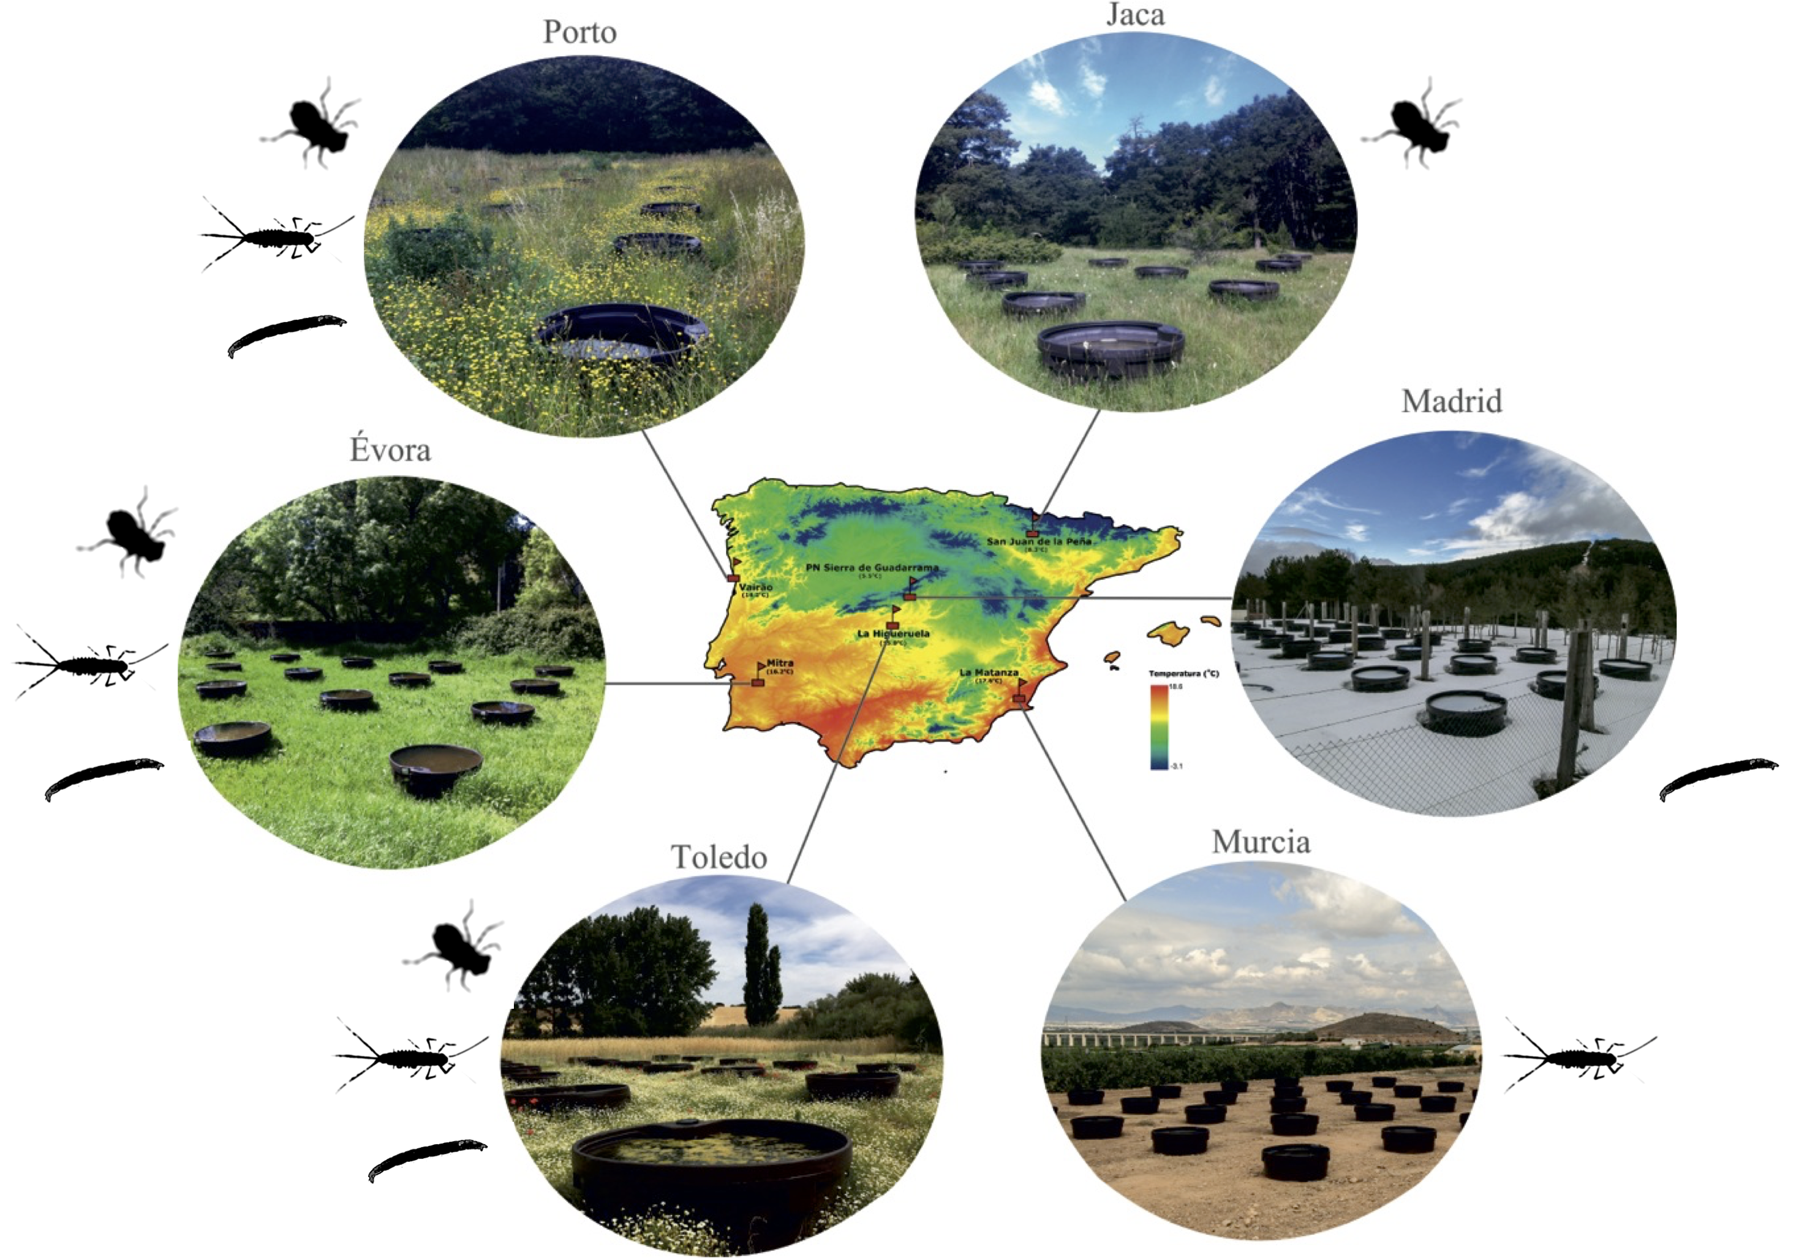

Figure S2. **The IberianPonds network is located in the thermally diverse Iberian peninsula.** The location of all six mesocosm experimental sites is shown with respect to a thermal map of the peninsula. Individual taxa sampled at each site are displayed (Jaca: *S. striolatum* alone; Madrid: *Chironomus* spp. alone; Murcia: *C. cloeon* alone).

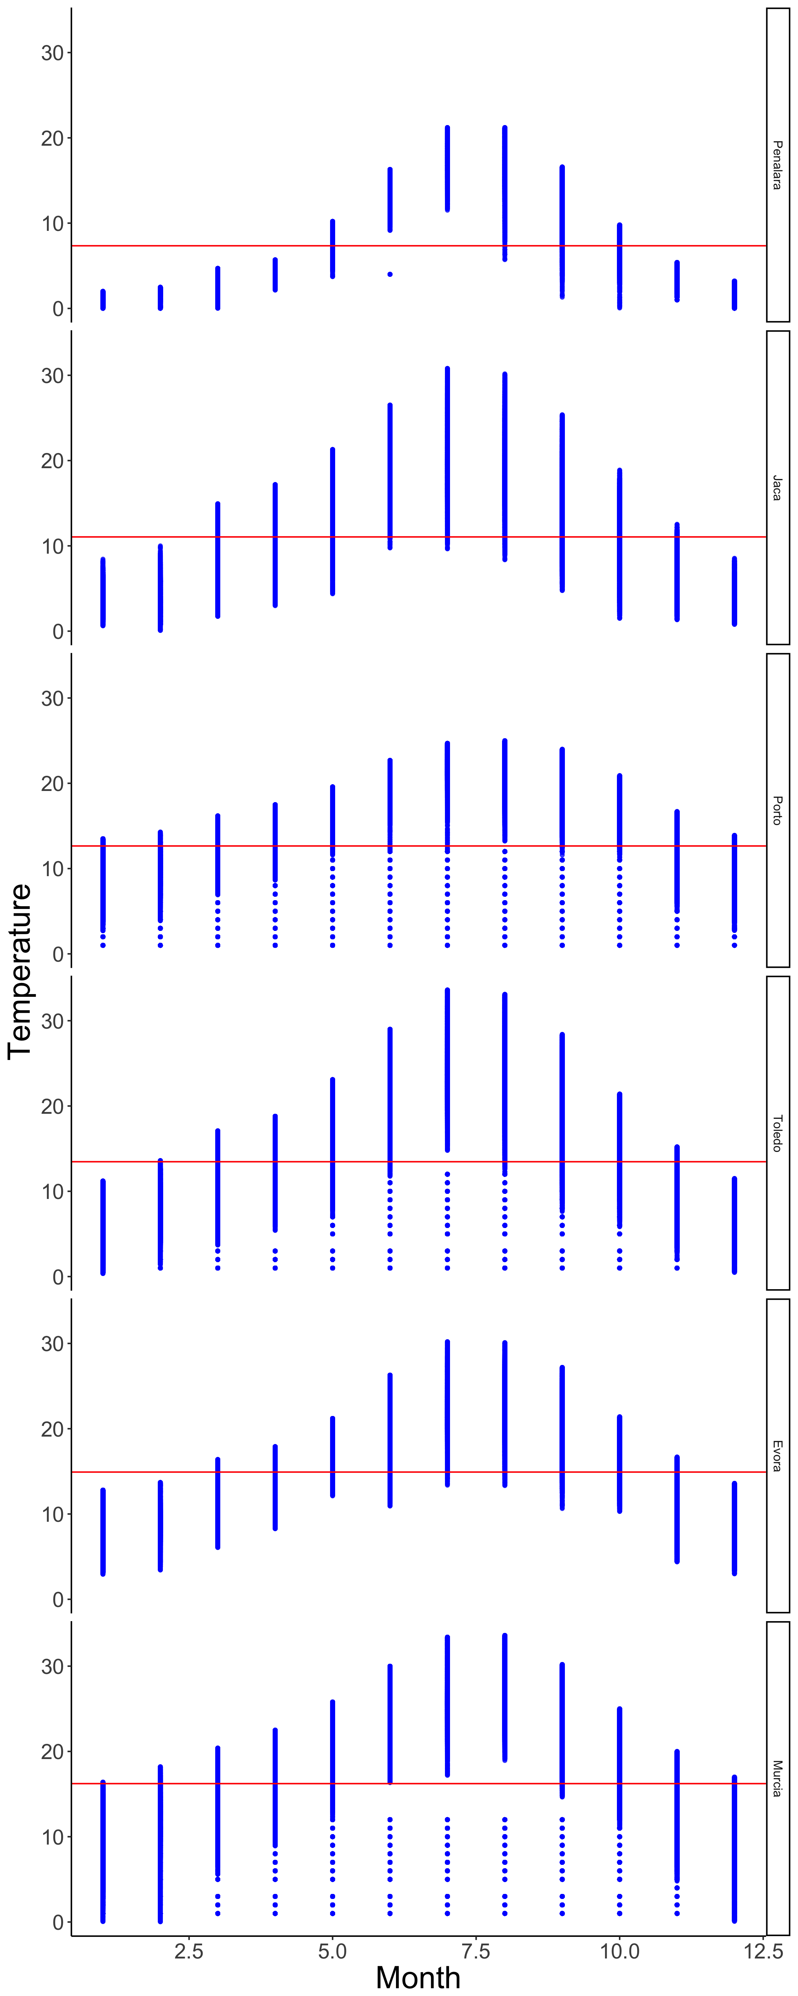

Figure S3 Recorded temperatures at each site. Temperatures recorded by loggers over 2-3 years plotted per month. Site mean temperature added in red.